PARISH COUNCIL MEETING
OF THE PARISH OF MANCETTER

Minutes of the Parish Council Meeting of the Parish of Mancetter,
held on Tuesday 25th January 2022 at the Schoolroom
of St Peter’s Church Mancetter,
commencing at 7pm.

Present:
Chairman Mr T Hopkins.

Parish Councillors Mrs S Healy, Mr P Mann and Mrs N Wallis.

County Councillor Mrs M Bell.
Borough Councillors Mr A Clews, Mrs D Clews.
PCSO E Jenkins.

Parish Clerk Mrs E Higgins.
Assistant Clerk Mrs K Meads.

One member of the public was also present and left following the public question time.

Item 1 - Welcome and Coronavirus Risk Assessment.

Mr T Hopkins welcomed everyone to the meeting at 7pm.
The meeting room was ventilated to minimise risk and despite a number of absences, the Council was quorate
to conduct business legally.

Item 2 – Apologies.

Apologies were received from Mrs G Forknall for pre-arranged annual leave and Mrs S Logie due to illness.
These apologies were accepted. Mr H Blackburn was absent for personal reasons.
Mr and Mrs Clews had given apologies, but were now able to attend due to their previous meeting finishing
earlier than expected.

Item 3 – Recording of the meeting.

There was no recording of the meeting.

Item 4 – Notice of Interest.

Mr T Hopkins declared an interest in Item 9e as an allotment holder.

Item 5 – Public Question Time.

Mr T Hopkins opened the floor to public questions. The resident in attendance is a member of the committee for the Gramer Trustees, who manage the Almshouses situated opposite and within the grounds of St Peter’s Church.

Firstly, the issue of the volume and speed of traffic was raised, and the resident asked whether 30 MPH could be painted onto the road either side of the approach to the cottages. The Chairman explained that unfortunately it was not legal to do this. A traffic and speed survey has taken place and a meeting with the County Highways is being arranged to discuss the findings and plan a way forward.

The Hedgerow within the cemetery that borders the cottages is beginning to affect the light levels within the nearest property and has become overgrown with Ivy. It was asked if the council could take action to deal

with the problem and perhaps extend the cemetery railings up to the area of the compost bays.

Responsibility for this boundary needs to be checked as it is believed to be that of the Almshouses.

Councillor Mann will photograph the area and further investigations will be made.

Post meeting note: Although the boundary does not belong to the Parish Council; partnership working has taken place with councillors and the cottages and cemetery groundsmen. As it is the dormant season, foliage has been cut back and steps taken to kill the ivy. Approximately 60 holly saplings growing wild on the allotment site, have been planted to encourage growth within the gaps, and it is hoped that some hawthorn and blackthorn whips can also be sourced.

Item 6 – Minutes of the last meeting.

The draft minutes from the 23rd November 2021 were agreed unanimously, and therefore formally signed by the chairman as a true record of proceedings.

Item 7 – Matters arising from the previous minutes.

- Tarmac Quarry.

A positive Quarry Liaison meeting took place on Wednesday 15th December 2021, attended remotely by 3 residents, a borough councillor, the clerk and councillors Hopkins and Mann. Now that Richard Price has returned as Quarry manager concerns over blasting have been addressed. The funding request for Rights of Way has been authorised by Richard and is with the Estates department. Work has already begun towards the eventual restoration of the site in preparation for the end of quarrying in 2025.

- Traffic and Speed Surveys, Speed watch

Graham Stanley from County Highways will be contacted to discuss the data from the Traffic and Speed Survey held in October 2021. There has been no further contact concerning training for Community Speed watch and support and confidence in the initiative has waned.

- Village Signs and Roman Heritage Board.

The Roman Heritage Board is ready to be sited at the Church.

Peter Mann distributed some copies of a possible design for the village gateway signs in Mancetter, focusing on Roman Heritage. The Civic Society have given permission to use the Heritage Centre Roman helmet logo, or alternatively, the parish council chariot image could be utilised.

The Ridge Lane signs will look to reflect the areas mining background.

The next steps will be:

- To obtain approval from County Highways for installation.
- Consult with parishioners on the designs and locations through publicity and the annual parish meeting.
- Finalise designs for both villages.
- Obtain costings.
- Put together funding requests.

Item 8– Feedback from Police, Borough and County Councillors.

- PCSO Emily Jenkins attended her first Mancetter Parish Council meeting.
She fed back that there had been 8 reports of anti-social behaviour, 3 instances of criminal damage and a robbery. Patrols at the golf course have also been targeting the issue of off-road bikes.

There is currently no warranted officer in our area which needs to be addressed.

- Margaret Bell the County Councillor for our parish informed the meeting that the court hearing for the travellers’ site at Kirby Glebe is set for 17th and 18th March.
Councillor Bell will speak to County Highways about a separate meeting to discuss the findings from the traffic surveys. Joint working with NWBC is still taking place on the drop kerbs in Lewis Close.

Parking in and around Atherstone is being decriminalised from 1st February 2022.

- Denise Clews confirmed that the Fir Tree Paddock planning application had been approved, but that stricter terms and conditions were being imposed. Grants are still available towards the Platinum Jubilee, and criteria will be checked to see if any planned activities will be eligible.

Councillor D Clews noted that the Cemetery water table was being discussed later in the agenda, as concerns are still being raised by some parishioners.

Item 9- Finance

- Two councillors signed the financial paperwork since the last meeting in accordance with Standing Orders and the Bank Mandate.
- It was proposed by Councillor Healy, seconded by Councillor Mann, and approved unanimously, to go ahead with the purchase of a Scribe Accounting System for record keeping, VAT and Audit.
- With the addition of an additional £100.00 for Rights of Way and the maintenance of a 2% forecasted uplift for staffing costs, the 2022-2023 Parish Council Budget was proposed by Councillor Wallis, seconded by Councillor Mann and agreed unanimously.
- Paperwork had been received in advance of the meeting, and following a detailed discussion, it was proposed by Councillor Healy, seconded by Councillor Wallis and approved unanimously to authorise an annual increase of £2.07 on a band D property. More detail will be included on the website and within the “Mancetter Matters” magazine.
- It was proposed by Councillor Healy, seconded by Councillor Wallis and agreed unanimously for the Chair to be given authority to collect the allotment rents for the forthcoming year. The waiting list will be reviewed and it was decided to maintain an annual rent of £14.00 per full allotment.
- Following a request from the Parish Council Rights of Way Contractor, it was proposed by Councillor Healy, seconded by Councillor Wallis and decided unanimously, to accept a price increase from April of £25.00 per quarter to help with rising fuel costs in maintaining our rural parish.
- In order to fund the purchase of the Jubilee trees in the dormant growing season, it was agreed unanimously to transfer adequate funds into the cemetery works reserve and then reduce the Jubilee budget being allocated for the next financial year. Future Reserves will be finalised at the next meeting.

Item 10– Platinum Jubilee

Councillor Hopkins has made 107 shields of 5 different designs using lightweight reclaimed wood. Councillor Mann is in the process of priming them. The plan is to display them on lamp posts around both villages within the parish, using cable ties attached to pre-drilled holes at the top and bottom of each shield. Local Community Groups will be helping to decorate the shields and a trail and prizes for different age groups is being considered.

2,000 tulip bulbs have already been planted around the parish, and on Mancetter Green the number “70” has been laid out with the dates “1952 – 2022” underneath.

Along with the 7 specialist trees in the cemetery, the parish council is hoping to create a commemorative display to be remembered in years to come.

Item 11 – Meetings and Training

- Councillor Healy attended the first WALC Local Climate Action Day on 19th January 2022. A five-minute video revealed that more environmental damage had been done in the last 5 years than in all the decades leading up to the Industrial Revolution. Sue has been researching local climate action plans, and will look to circulate some templates at a future meeting. She has been working alongside the Eco-Warrior author in the “Mancetter Matters” magazine and will be reviewing existing council policies to include environmental information. Councillor Hopkins has worked on some Climate Change Mnemonics that the council could consider adopting.

- Following on from a briefing session on the “20 is Plenty” initiative, Mancetter Parish Council agreed unanimously to pledge support for the campaign to reduce speed in our built-up areas.

- The Chairman and the Clerk attended some Rights of Way training this morning. There were some interesting points raised, and some legal areas where challenges can be made.

Item 12- Planning Matters and New Applications. Update on recent applications, enforcement issues
and determinations from planning lists.

The list of pending and approved applications was noted by Councillors.
The Council has no objections to the Single Storey Rear Extensions planned for 64 and 86 Mancetter
Road referred to within PAP/2021/0675 and PAP/2021/0386.

Item 13– Cemetery and Maintenance around the Parish.

- A lengthy discussion took place around the issue of waterlogged ground towards the bottom of the cemetery. Interestingly it only tends to be a problem on the right hand side as you face uphill from the river. This may indicate the presence of an underground water course, and this needs further investigation.
The possibility of planting additional trees /bushes in that area was considered, but this could cause a bigger issue as the roots spread out seeking nutrients. The Council may have to consider other options and take further advice.

- The last two sections of the railings have been completed and a letter of recommendation will be sent to Eagledale for the excellent job they have done. You cannot see a difference, which in the conservation area is a resounding success. The Parish Handyman will continue to paint the railings as the weather improves.

- In order to prevent cremation plots having large gaps in between, it was agreed to price up some slabs cut to the size of a memorial stone to keep the area tidy and not lose any spaces.

- The Invoices for Tom White Waste are now coming through regularly and approval for the payment of a £52.00 fee for processing waste disposal documentation was approved unanimously.

- The Council will have a look at the overhanging yew branches and organise for some light pruning if required. No responsibility will be taken for any repairs to boundary walls, should the Church choose to place a skip in the carpark.

Item 14 - Date of next meeting:
Tuesday 22nd March 2022 7pm at the Schoolroom, St Peter’s Church Mancetter.
As there was no further business the meeting closed at 9.30pm.

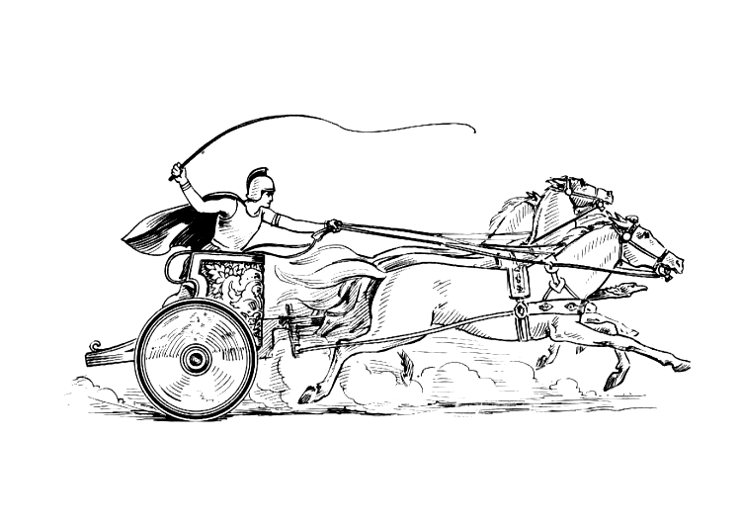

Manduessedum - Mancetter Village
(Place of War Chariots)
Mancetter Parish Council
Serving the People of Mancetter and Ridge Lane

